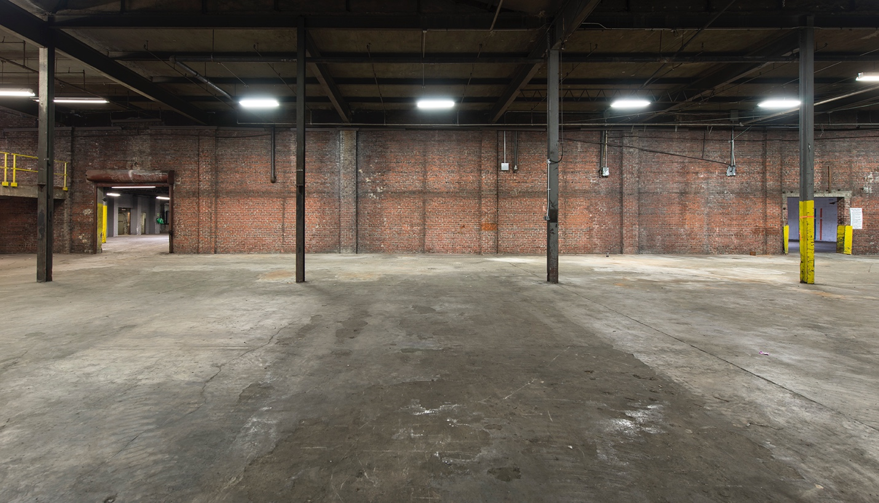
For Immediate Release
The Temporary Art Center Announces Opening—and Closing—in 2019

Atlanta, GA – (September 9, 2019) – The Temporary Art Center announces it will open—and close—in Atlanta in 2019 with a celebration and opening reception November 15, 8:00–10:00 p.m. (VIP 6:00-8:00 p.m.). Occupying the 66,000 sq. ft. Conklin Metal Building located on the burgeoning Memorial Drive Corridor, the Center is a celebration of Atlanta’s visual art community and is the centerpiece of an imagined future.

The Temporary Art Center will open its inaugural exhibition on November 15 with the exhibition PROJECT, which will run through late December. The Center’s closing date is subject to the demolition schedule of the building, which is slated for redevelopment in 2020. The Temporary Art Center is the realization of a collective vision for the Atlanta arts ecosystem. It is rooted in the fertile soil of Atlanta’s present, to offer a vision for the future.

The concept for the show was taken from the now famous 1988 Freeze exhibition that artist Damien Hirst organized in London that launched the careers of so many of the Young British Artists. PROJECT highlights Atlanta-based artists whose work has a thriving presence in exhibitions and markets outside Atlanta. As a counterpoint, it also features artists that once called Atlanta home, having departed to pursue opportunities in other cities, yet remaining connected to and influenced by Atlanta. Many of the participating artists will challenge themselves to produce work at a monumental scale, made possible by The Temporary Art Center’s expansive industrial architecture.

PROJECT includes artists: Paul Stephen Benjamin, Fredrik Brauer, Marc Brotherton, Xie Caomin, Bethany Collins, Drew Conrad, William Downs, Shanequa Gay, Jill Frank, Kojo Griffin, Dana Haugaard, Sarah Hobbs, Lonnie Holley, Shara Hughes, Scott Ingram, Wihro Kim, Michi Meko, Kirstin Mitchell, Jiha Moon, Esteban Patino, Fahamu Pecou, Joe Peragine, Jen Ray, Micah and Whitney Stansell, Ben Venom, JD Walsh, Christina West, and Sonya Yong James.

“The Temporary Art Center is interested in developing a new model for the way Atlanta invests in and supports its artists to create a more vibrant and sustainable community for our artists. So many artists get their start in Atlanta but must leave to further their careers. We are trying to create more reasons for artists to stay,” says TAC Founder and Curator Scott Ingram. “This is 100% about creating awareness for the talented artists working in Atlanta while also making it clear that we’ve lost a lot of Atlanta’s talent, and will continue to do so if we don’t change the model. The show is called PROJECT, as in “a project” or more importantly “to project”. This is an opportunity to assemble our collective energies and resources to really showcase Atlanta’s talent. We need to project out, to bring interest back in.”

In addition to the large-scale exhibition PROJECT, The Temporary Art Center will present a variety of projects to animate Atlanta’s newest contemporary art center including educational programs, a mini-art fair for Georgia State University’s MFA students, and gift shop featuring publications, merchandise and limited-edition multiples. Proceeds from sales support the exhibition.

Weekend events will be scheduled throughout the Center’s period of operation, including a day-long public symposium on November 16 in partnership with Art Papers as well as artist talks and performances. The schedule will be posted on the Center’s website.

PROJECT is sponsored by Perennial Properties, Hathaway Gallery, Faulkner + Locke and Georgia State University College of Art.

About The Temporary Art Center
Conceived of by Atlanta-based artist, Scott Ingram, The Temporary Art Center is free and open to the public. Visit www.temporaryartcenter.com for hours of operation, the programming schedule and further announcements.

The Conklin Metal Building is located at 236 Moore Street SE, Atlanta, GA 30312.

About The Curator
Scott Ingram is an Atlanta-based artist who exhibits locally and internationally. He is represented by galleries in Atlanta, Chicago and San Francisco, and has work in the collections of the High Museum of Art, Weiland Family Collection and the Museum of Contemporary Art Georgia to name a few. His most recent curatorial endeavor was the critically acclaimed exhibition …til the lights go out, at the former Hathaway Contemporary Gallery called one of the best exhibitions of 2018 by ArtsATL.org.

For Inquiries contact Scott Ingram: scottaingram@mac.com or 404-423-6651
Please visit the website for hours of operation: www.temporaryartcenter.com

Photo Credit: Fredrik Brauer

###

